SCIP Services
SCIP’s Partners
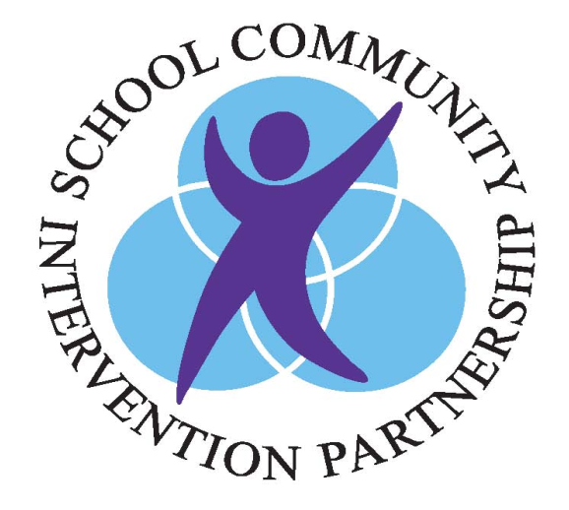


SCIP Consultants will work with your family in a confidential, supportive manner by:

- Meeting with you and school personnel to better understand your child’s strengths and challenges and provide recommendations for services

- Working together to increase your child’s ability to be successful in a classroom setting

- Helping your family to connect with community resources

- Providing rapid access to psychiatrist and / or a pediatrician if appropriate for assessment and stabilization- care is returned to the referring physician

- Attending appointments with you and your child for additional support

- Providing information and support to further develop helpful parenting skills

- Working together to develop a plan that addresses your needs








Here’s what some of our clients have told us about our services:

“I have learned so much with the SCIP program, including how to help my child, my family and myself.”

“Great liaison between the school and us.”

“Great strategies for our child at school and home.”

“I felt the SCIP Consultant was very supportive to me and my family through a difficult time.”

SCIP



Effective Early Intervention
for Children with
Difficulties in Emotional and Behavioural Self Regulation

September, 2020

SCIP services could be helpful if
you have a child in grades 1-5 struggling with:

- Attention Problems
- Hyperactivity/Impulsivity
- Following/challenging rules
- Noncompliant/defiant behaviours
- Becoming argumentative
- Academic performance below apparent ability/school refusal
- Emotional dysregulation/mood swings/withdrawn/avoidant
- Becoming easily frustrated/disruptive
- Feeling excessively sad
- Temper outbursts
- Interpersonal relationships/social skills
- Feeling anxious/ fearful/ overwhelmed
- Anger/being resentful
- Blaming others for his/her mistakes
We believe that positive outcomes happen when we work together to develop strength based goals.
SCIP is
- Voluntary
- Available in all schools
- Free
- For children in grades 1-5 who are struggling with regulating their behaviours at school, home and/or in the community
- Team oriented with school personnel and families
- Flexible
  - meeting time/ location
  - length of service

SCIP is NOT
- Counselling and therapy
- A crisis service
- Intensive “in home” support/treatment
- A service that works directly with your child
- A long term service
.

SCIP accepts referrals from designated schools in the following school boards:

- Conseil scolaire catholique Providence
- Conseil scolaire Viamonde
- London District Catholic School Board
- Thames Valley District School Board

Referrals must be submitted by the school team with parent’s consent.

For more information
please contact us:

Vanier Children’s Mental Wellness
871 Trafalgar Street
London, Ont.
N5Z 1E6
P:519-432-0881
F:519-432-0056
Email: information@scipinlondon.com

